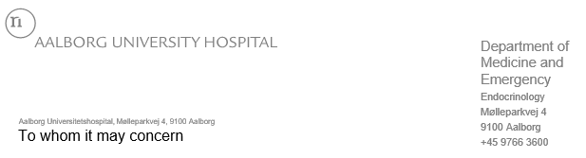

5 januar 2023

Medical certificate

Diabetes patient treated with injections

This document certifies that
Name:
Date of birth:
has diabetes treated with injections and needs to carry medicine as well as equipment for injection and blood glucose monitoring on the body or in the hand luggage.
Insulin pumps and/or equipment for continuous glucose monitoring should not be removed from the body when the person goes through security controls. Please, be aware that these devices may be damaged when exposed to x-rays and full body scanners.

For further information or questions, please contact:
Steno Diabetes Center
North Jutland
DENMARK
Phone +45 97 66 36 00

Yours sincerely,
Department of Steno Diabetes Center

